FINGERPRINT IMAGE ENHANCEMENT

Based on

Local ridge orientation and ridge frequency estimation

Project submitted in partial fulfillment of the requirement for the degree of B. Tech in

Computer Science and Engineering under

Maulana Abul Kalam Azad University of Technology, Kolkata



*ABACUS INSTITUTE OF ENGINEERING & MANAGEMENT*

NATUNGRAM, MOGRA, HOOGHLY

Submitted by

DEEPSHIKHA

University Roll No. – 24000116040

Under the Supervision of

Prof. Sudeshna Das

Asst. Professor of Computer Science & Engineering Department. ABACUS INSTITUTE OF ENGINEERNG & MANAGEMENT APPROVAL

This is to certify that the project report entitled “FINGERPRINT IMAGE ENHANCEMENT based on Local ridge orientation and ridge frequency estimation” prepared under my supervision by*(DEEPSHIKHA (24000116040),* be accepted in partial fulfillment for the degree of Bachelor of Technology in Information Technology.

It is to be understood that by this approval, the undersigned does not necessarily endorse or approve any statement made, opinion expressed or conclusion drawn thereof, but approves the report only for the purpose for which it has been submitted.

TABLE OF CONTENTS

Sl. No. Topics Page No.

1. Introduction

2. Problem Definition

3. Literature Survey

4. Software Requirement Specification

5. Planning

6. Design

7. Algorithm

8. Implementation Details

9. Implementation of Problem

10. Result

11. Discussion

12. Conclusion

13. Future Scope

14. Reference

15. Appendix

INDEX OF IMAGES

Fig. No. Topics Page No.

1.1 Correcting non-uniform illumination

1.2 Histogram Equalization

1.3 Wiener filter

1.4 Minutiae

2.1 Source-Enhanced Image

6.1 Flow Chart

9.1 Normalized Image

9.2 Ridge Frequency Image

9.3 Filter Diagram

10.1 – 10.5 RGB to GRAY code screenshots

10.6 – 10.10 Output for different samples(RGB to GRAY)

10.11 – 10.18 RGB to HSV code screenshots

10.19 – 10.23 Output for different samples(RGB to HSV)

10.24 – 10.28 PSNR screenshots

11.1 Bar Graph

11.2 Linear Graph

INDEX OF TABLES

Sl. No. Topics Page No.

4.1 Hardware Requirements

4.2 Software Requirements

5.1 Planning

11.1 Comparison Table

1. INTRODUCTION

Image Enhancement is the process of digitally manipulating a stored image using

software. The tools used for image enhancement include many different kinds of software such as filters, image editors and other tools for changing various properties of an entire image or parts of an image.

Some of the most basic types of image enhancement tools simply change the contrast or brightness of an image or manipulate the grayscale or the Red-Green- Blue colour patterns of an image. Some types of basic filters also allow changing a colour image to black and white, or to a sepia-tone image, or adding visual effects.

More sophisticated types of image enhancement tools can apply changes more specifically to certain parts of an image. It is one of the most important and difficult techniques in image research. The aim of image enhancement is to improve the visual appearance of an image, or to provide a “better transform representation for future automated image. The existing techniques of image enhancement can be classified into two categories:

1. Spatial Domain Frequency domain enhancement.

Spatial based domain image enhancement operates directly on pixels. The main advantage of spatial based domain technique is that they conceptually simple to understand and the complexity of these techniques is low which favors real time implementations.

2.Frequency based domain, the basic idea in using this technique is to enhance the image by manipulating the transform coefficients. The advantages of frequency based image enhancement includes low complexity of computations, ease of viewing and manipulating the frequency composition of the image and the easy applicability of special transformed domain properties.

If enhanced image embed high quality background information, the

existing techniques of image enhancement like spatial domain methods can again be classified into two broad categories: Point Processing operation and Spatial filter operations. Frequency domain methods can again be classified into three categories: Image Smoothing, Image Sharpening, Periodic Noise reduction by frequency domain filtering. Image enhancement algorithms include deblurring, filtering, and contrast methods.

Here are some useful examples and methods of image enhancement:

1. Filtering with [morphological operators](https://in.mathworks.com/help/images/examples/correcting-nonuniform-illumination.html)

2. [Histogram equalization](https://in.mathworks.com/help/images/contrast-adjustment.html#buh9ylp-59)

3. Noise removal using a [Wiener filter](https://in.mathworks.com/help/images/examples/deblurring-images-using-a-wiener-filter.html)

4. [Linear contrast adjustment](https://in.mathworks.com/help/images/adjust-image-contrast-in-image-viewer-app.html)

5. [Median filtering](https://in.mathworks.com/help/images/noise-removal.html#buh9ylp-71)

6. [Un-sharp mask filtering](https://in.mathworks.com/help/images/apply-filter-to-region-of-interest-in-an-image.html)

7. Contrast-limited adaptive histogram equalization ([CLAHE)](https://in.mathworks.com/help/images/ref/adapthisteq.html)

8. [Decorrelation stretch](https://in.mathworks.com/help/images/ref/decorrstretch.html)

:

For example, you can remove noise, sharpen, or brighten an

image, making it easier to [identify key features.](https://in.mathworks.com/help/images/pixel-values-and-image-statistics.html)

The following images illustrate a few of these examples:

1. [Correcting non-uniform illumination with morphological](https://in.mathworks.com/help/images/examples/correcting-nonuniform-illumination.html) operators.

2. 1.1

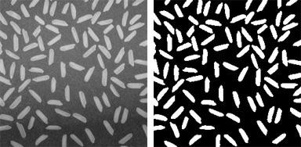

1.2

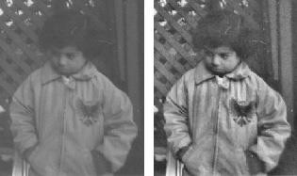

Enhancing grayscale images with [histogram equalization.](https://in.mathworks.com/help/images/contrast-adjustment.html#buh9ylp-59)

3.Deblurring images using a [Wiener filter.](https://in.mathworks.com/help/images/examples/deblurring-images-using-a-wiener-filter.html)

Fingerprint Image Enhancement

1.3

A fingerprint is the feature pattern of one finger. It is believed with strong evidences that each fingerprint is unique. Each person has his own fingerprints with the permanent uniqueness. So fingerprints have being used for identification and forensic investigation for a long time.

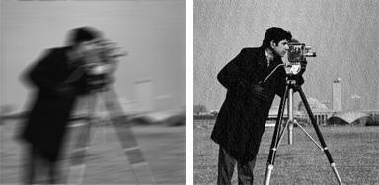

Fingerprint identification is one of the most important biometric technology which has drawn a substantial amount of attention recently. The uniqueness of fingerprint is exclusively determined by the local ridge characteristics and their relationships.

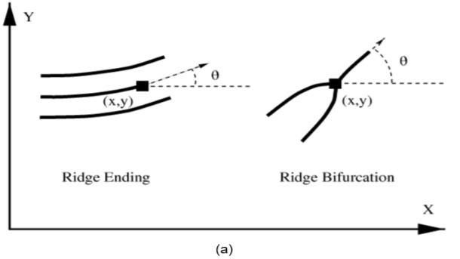

1.4

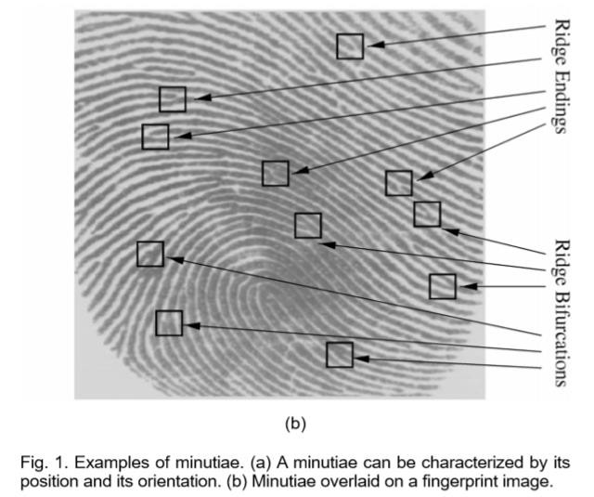

A total of 150 different local ridge characteristics (islands, short ridges, enclosure, etc.) have been identified. These local ridge characteristics are not evenly distributed. Most of them depend heavily on the

impression conditions and quality of fingerprints and are rarely observed in fingerprints.

The two most prominent local ridge characteristics, called minutiae, are

1. Ridge ending

2. Ridge bifurcation.

A ridge ending is defined as the point where a ridge ends abruptly.

A ridge bifurcation is defined as the point where a ridge forks or diverges into branch ridges.

A good quality quality fingerprint typically contains about 40–100 minutiae. Examples of minutiae are shown in Fig. 1.

Automatic fingerprint matching depends on the comparison of these local ridge

characteristics and their relationships to make a personal identification. A critical step in fingerprint matching is to automatically and reliably extract minutiae from the input fingerprint images, which is a difficult task.

The performance of a minutiae extraction algorithm relies heavily on the quality

of the input fingerprint images. Fingerprint verification is to verify the authenticity of one person by his fingerprint. The user provides his fingerprint together with

his identity information like his ID number.

The fingerprint verification system retrieves the fingerprint template according to the ID number and matches the template with the real-time acquired fingerprint from the user. Usually it is the underlying design principle of AFAS (Automatic Fingerprint Authentication System).

Fingerprint Image enhancement is to make the image clearer for easy further operations. Since the fingerprint images acquired from sensors or other Medias

are not assured with perfect quality, those enhancement methods, for increasing the contrast between ridges and furrows and for connecting the false broken points of ridges due to insufficient amount of ink, are very useful for keep a higher accuracy to fingerprint recognition

2. PROBLEM DEFINITION

The Fingerprint Image Enhancement alters the visual impact that the image has on the interpreter in a fashion to improve the information content.

In this project we will try to enhance the fingerprint image automatically by an evolutionary algorithm without any human intervention. Enhancement of an image becomes a difficult and challenging task due to various perturbations present in those images.

In this project we have proposed a novel method to enhance an image without human intervention.



By summing up various mathematical enhancement functions a combined enhancement function is being created.



The performance of the proposed method is found to be superior to that of the state-of-the-art methods for image enhancement on standard data set.



2.1

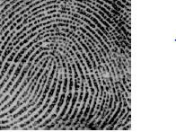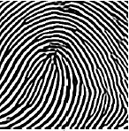

(a) Input image (b) Enhanced image

3. LITERATURE SURVEY

This project presents the work done by other researcher related to Fingerprint image enhancement system, pores extraction and matching system. Some of the reference papers are summarized below.

Lin Hong Yifei Wan, and Anil Jani [1] A fast fingerprint enhancement algorithm which can adaptively improve the clarity of ridge and valley structures based on the local ridge orientation and ridge frequency estimated from the inputted image is introduced. The performance of the algorithm was evaluated using the goodness index of the extracted minutiae and the performance of an online fingerprint verification system which incorporates our fingerprint enhancement algorithm in its minutiae extraction regions of these images. As part of the proposed system, using Band Object control, they build a Tool bar named “Filter Tool Bar (FTB)” by modifying the Pavel Zolnikov implementation. In the proposed system, they introduce three new methods for extracting images from the web pages (after loading the web page by using the proposed FTB, before loading the web page physically from the local host, and before loading the web page from any server). These methods overcome the drawback of the regular expressions method for extracting images suggested by Ilan Assayag. The second part of the proposed system is concerned with the detection of the skin color regions of the extracted images. So, they studied two famous skin color detection techniques. The first technique is based on the RGB color space and the second technique is based on YUV and YIQ color spaces. They modified the second technique to overcome the failure of detecting complex image’s background by using the saturation parameter to obtain an accurate skin detection results. The performance evaluation of the efficiency of the proposed system in extracting images before and after loading the web page from local host or any server in terms of the number of extracted images is presented. Finally, the results of comparing the two skin detection techniques in terms of the number of pixels detected are presented.



4. SOFTWARE REQUIREMENT SPECIFICATIONS (SRS)

HARDWARE REQUIREMENTS

RAM 4 GB

MINIMUM SPACEREQUIRED

10 GB

Table 4.1. (Hardware Requirements Table)

SOFTWARE REQUIREMENTS

Operating Platform WINDOWS 10/10PRO

Internet Connection 1MBps

Tools MATLAB 2018a

Operating System Type 64 bit

(Software Requirements Table)

5. We developed this project as per the iterative waterfall model:

5.1

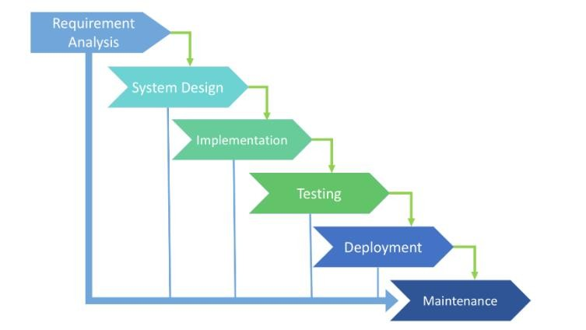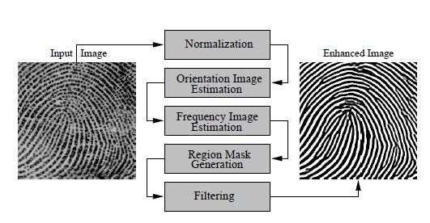

6. FLOW CHART

7. ALGORITHM

6.1

The flowchart of the fingerprint enhancement algorithm is shown in Figure above. The main steps of the algorithm include:

Step 1: Normalization: An input fingerprint image is normalized so that it has a pre-specified mean and variance.



Step 2: Local orientation estimation: The orientation image is estimated from the normalized input fingerprint image.



Step 3: Local frequency estimation: The frequency image is computed from the



normalized input fingerprint image and estimated orientation image.

Step 4: Region mask estimation: The region mask is obtained by classifying each block in the normalized input fingerprint image into a recoverable or a unrecoverable block. input fingerprint image to obtained an enhanced fingerprint



Step 5: Filtering: A bank of gator filter which is turned to local ridge orientation and ridge frequency is applied to the ridge and furrow pixels in the normalized input fingerprint image to obtain an enhanced fingerprint image.



NORMALIZATION:

It is the first step in the enhancement algorithm. Normalization is done so that the gray level values lies within a given set of values. The fingerprint image is normalized to have a predefined mean and variance. This is required as the image usually has distorted levels of gray values among the ridges and the valleys. Normalization allows to standardize the distorted levels of variation in the gray scale values. Normalization involves pixel-wise operations and does not change the ridge and valley structures.

Normalization is a linear process. Suppose the intensity range of the image is 50 to 180 and the desired range is 0 to 255 the process entails subtracting 50 from each of pixel intensity, making the range 0 to 130. Each pixel intensity is multiplied by 255/130, making the range 0 to 255.

9.1

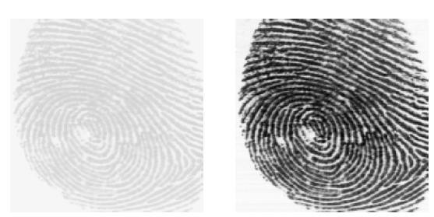

(a) input image (b) normalized image

Histogram equalization, as normalization method, is a process to enhance the contrast of images by transforming its intensity values. Usually a fingerprint image has different gray values for every pixel. It is desirable to have the gray value around a mean value. This is achieved by histogram equalization. It increases the local contrast of images. Thus the intensities can be distributed on the histogram. This allows for areas of lower local contrast to gain a higher contrast without affecting the global contrast. Histogram equalization accomplishes this by effectively spreading out the intensity values.

RGB to GRAY :

8.RESULT

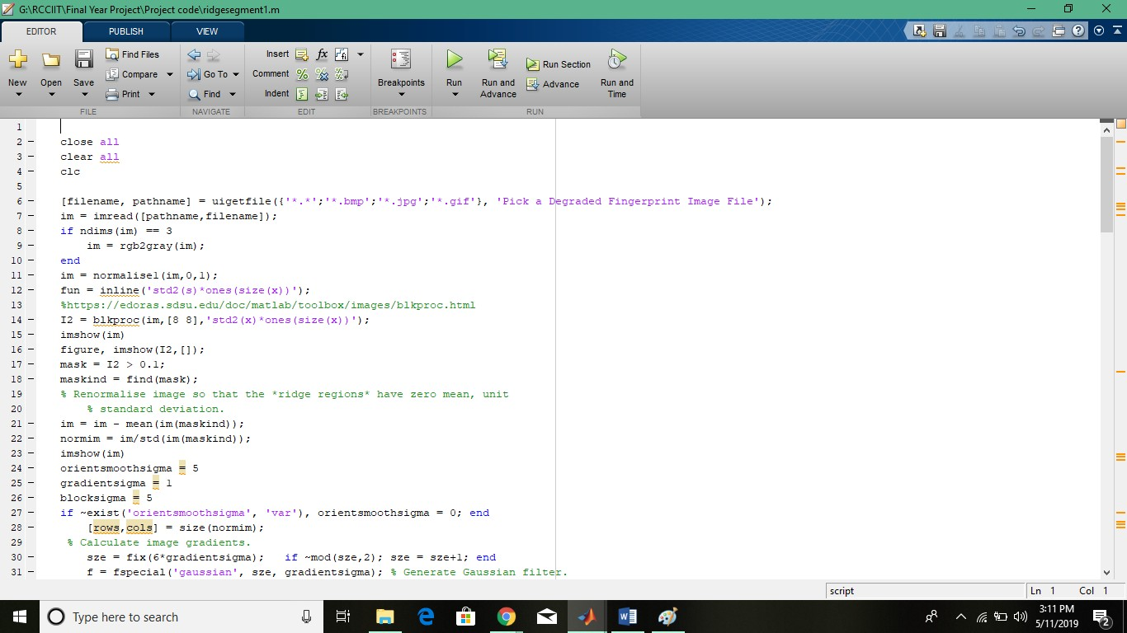

Figure 8.1

OUTPUT FOR DIFFERTENT SAMPLES

1. Sample No.1

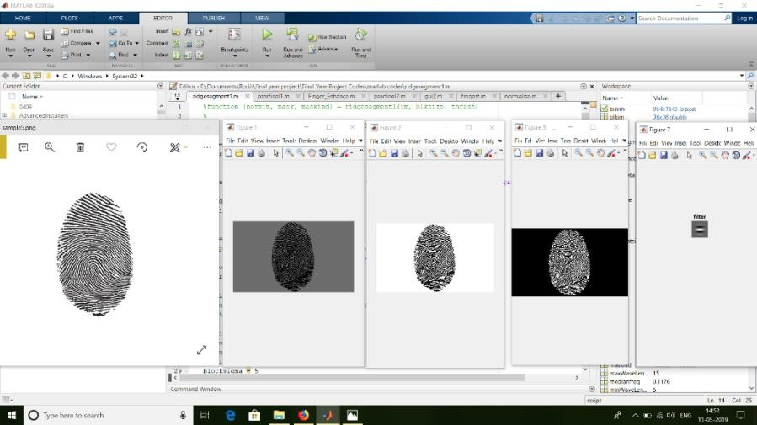

**9. DISCUSSION**

We have calculated the PSNR (Peak Signal To Noise Ratio) values of different sample images for both the techniques i.e. RGB to GRAY and RGB to HSV. We have represented it in the form of a **Bar Graph**, a **Linear Graph** and a **comparison table**.

**10. FUTURE SCOPE**

**1.** To perform statistical experiment used in this project on a larger sample size & a conduct a full analysis of observed result.

2. An implementation of a Enhancement algorithm should be able to improve the verification & identification process.

3. Issue need to be addressed in the systematic way in developing a fool proof fingerprint based Enhancement system for a wide scale development e.g. encryption security of fingerprint template detection of force fingers, privacy concern etc.

4. Implementation of on-line fingerprint Enhancement system using biometric device.

5. We can use this type of Enhancement algorithm in area such as bank locker system, car ignition, punch card system, electronic safe for vehicles, to secure some important section in company & also in government office, etc.